Final Project Design Phase
Computer Science - Week 11
Oct 3, 2026 - Version 0.0.4

For complete instructions and project ideas, refer to the assignment in Canvas. Specifically, review the final project requirements before you continue below. If you have not reviewed the project requirements in Canvas (you might have to go to the modules view and check the current or past week's content), you will not be able to properly complete the parts below. In addition, it may be helpful to review the information on this Drafter documentation page.

0) Project Planning and Preparation
Successful programmers spend time planning before they begin coding. After reviewing the project requirements, answer the following questions to help guide your design and development process.
- What concepts from class or previous assignments might help you complete this project? Which programming concepts (loops, conditionals, lists, classes, etc.) do you expect to use? What programming skills do you want to improve while completing this project?
Conditionals and classes are a big deal for the project that I am doing because how the game plays out depends on certain things being true or not and I need to keep track of many variables that change as the game progresses which classes are good for.

- Which parts of the project do you expect to be the easiest for you? The hardest? Why?
I think the easiest part will be formatting the sites to look how I want because that is pretty straightforward on what you can and can’t do and the hardest will be making sure that the math works out for scoring and that the code accounts for every condition in the game.

- Even though you have not yet designed the final project, estimate which tasks will likely require the most time and effort? Which features or components should be implemented first?
I think the parts that will take the longest are scoring hands and automating the dealer to draw cards. I should probably just implement a way to make a deck of cards and draw them first as a starting point.

- What distractions might interfere with your work and how will you minimize them? What resources will you need available while working? What questions, if any, do you still have about the assignment requirements?
Other classes might take over and be a distraction but I can allot time every day or every other day specifically for this. I will need the drafter code options available so that I know what I can and can't do in my website and the syntax.

1) Site Diagram
Create a mock-up of your planned website. We suggest you make the mockup on paper, although you can also use software like PowerPoint or Slides to make a mockup. There is other design software that could also be used, but we strongly encourage you to keep it simple. Do not spend more than 15-30 minutes detailing the mock-up. Your goal should be to make a very quick and dirty diagram, to show that you have some kind of idea.

We recommend drawing each page as a rectangle, and laying out the text, buttons, and other components inside. Then, use arrows to indicate links between pages. Label each page the way you will name each function, and then put labels on the arrows to indicate what the button links. Also write down any parameters that should come into the pages.

In addition to the pages and routes, write down what fields your `State` will have, both their names and types. Think clearly about what data will need to be persistent across the entire website.

Add photo(s) or screenshot(s) of your website mock-up and labeled diagram on the next page.

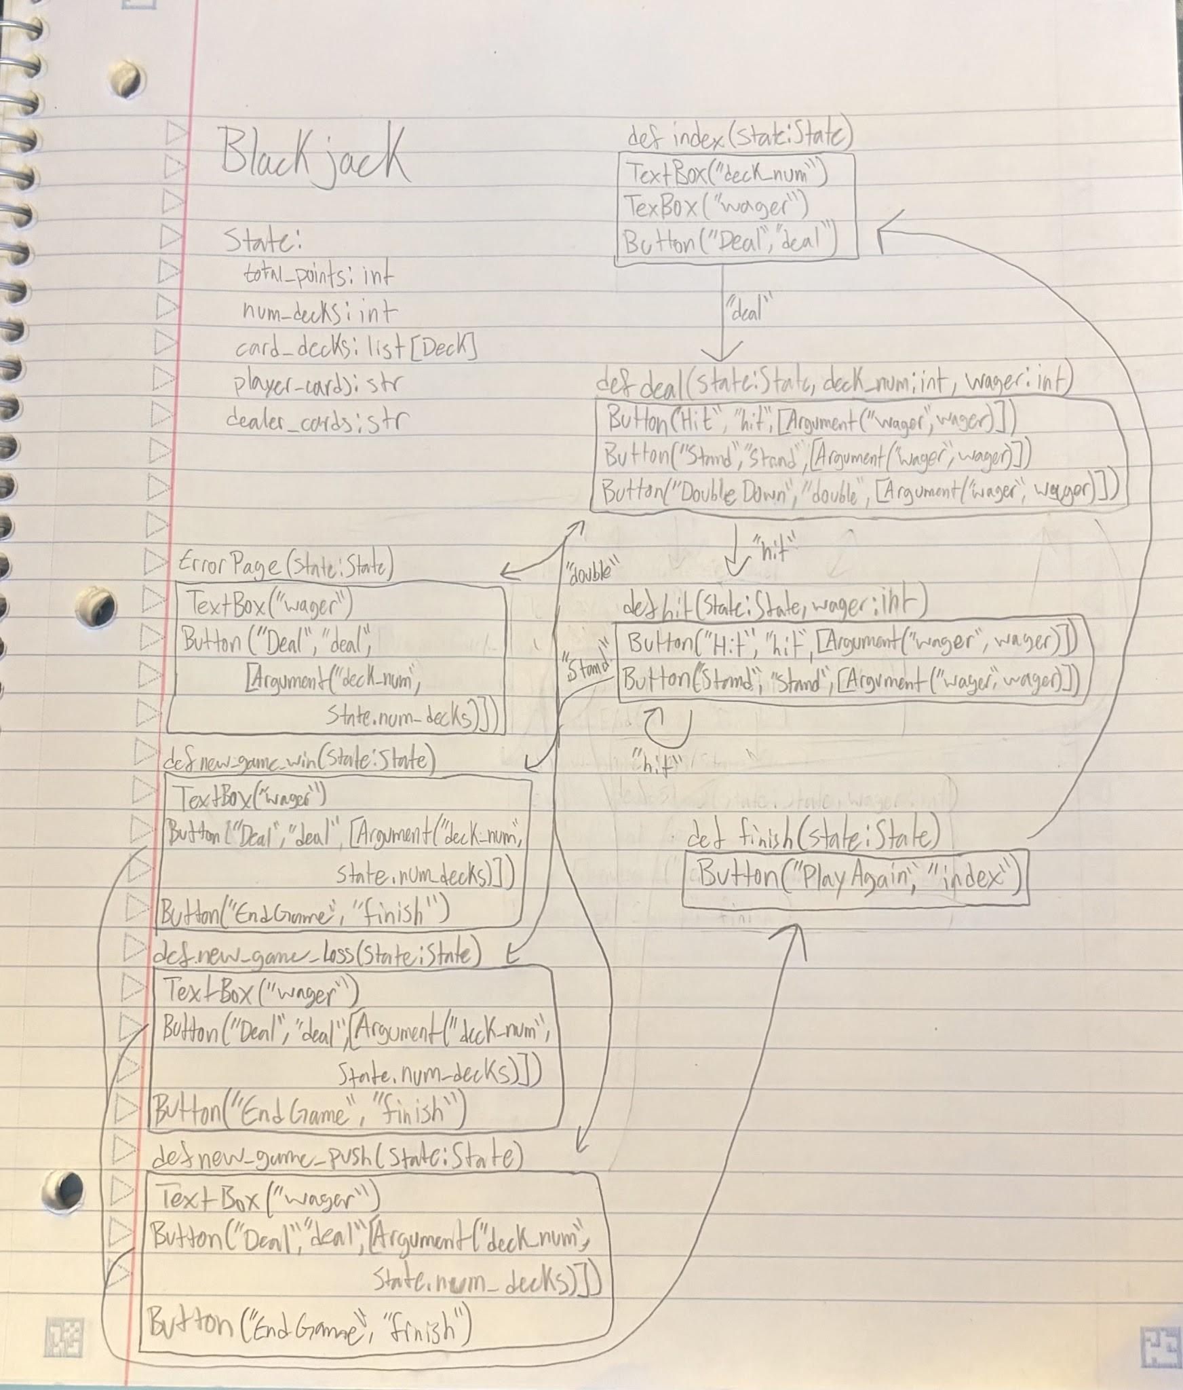
2) Implementing Requirements
This table should serve as a draft for how you will implement the requirements into your final project. You may change your ideas later on, but your final site must fulfill all the requirements.

Requirement | Implementation
Purpose/Functionality  A 1-2 sentence description of the purpose or functionality of your site | The purpose of my game is to create a fun, realistic game of blackjack that people can have fun playing and compete for most points.
State Dataclass Attributes  Minimum of 4 attributes, one of which must be a list/dict of instances of your second dataclass.  Briefly describe each attribute, its type, and how it will be meaningfully modified throughout the site. | total_points: int, tracks the number of points the player has at all times, goes up or down based off wins and losses  num_decks: int, the number of decks the player wants to play with, can be changed at the start of each game and is used to reshuffle cards when they run out  card_decks: list[Deck], the list of actual cards, the number of decks is determined by num_decks and after a card is used, it is removed from the list  player_cards: str, the two cards the player is dealt, more cards can be added on if the player hits  dealer_cards: str, the two cards the dealer deals, more cards can be added if the dealer needs more
Second Dataclass  Your second dataclass, including its attributes, their types, and how they will be meaningfully modified (if they are modified) | Deck:  deck: List[str]  Each deck is its own individual deck of 52 cards, this is modified when the player says how many decks they want and when the player plays, cards must be removed from the decks
Routes (minimum 7)  The names of your route functions | Index, new_game_win, new_game_loss, new_game_push, deal, hit, stand, double, finish
Pages (minimum 5)  A brief description of the pages in your site | The first page is the index page, shows the title, the total points for the player, and asks how many decks they want and how many points they want to wager  The next page is the deal page, once the player presses deal, the page will show them the cards they were dealt, one of the cards the dealer was dealt, and the options to hit, stand, or double down  If the player chooses hit, they get a new page with their updated cards after adding one, then they get the option to hit or stand again but they can’t double  There are also some error pages where the player will be asked to reenter their wager if they try to wager more points than they have, also they are not given the option to double down if double of their wager is more than what they have total  If the player chose to stand, they will get one of three pages depending on whether they won, lost, or pushed. Each page shows their final cards and the dealers final cards after the dealer tries to beat them and then their total points, they also get the option to make a new wager for the next hand and deal, or to finish the game  The last page is the finishing page when the player is ready to stop playing, it shows their total score which is how many total points they won or lost and a message depending on their score and then the option to play again which resets their points.
User Input (minimum 3)  Description of user input components (TextBox, TextArea, CheckBox, or SelectBox) and their purposes  For more information on these input types, see Drafter Documentation. | The user has to input the number of decks they want to use at the beginning of the game and the wager they want to put on the first hand. That wager must be reentered with every new hand.
If Statements (minimum 3)  Brief description of what will be evaluated in your if statements and how they will meaningfully change the logic of the site | Three meaningful If statements are the scoring ones at the end of each round. They evaluate the score of the player's hand and the score of the dealer's hand and return whether the player won, lost, or pushed. This can increase, decrease, or maintain the players overall score and returns a new page detailing all this info to the player
Loop (minimum 1)  This loop must iterate over the list/dict of dataclass instances in your State attribute.  Description of this loop and why it is meaningful to the site | The loop that iterates over my dataclass list in State is a while loop in the function that deals cards. The loop ensures that the Deck class and the deck attribute are not empty while it is dealing cards and if it is empty, it reshuffles and makes a new deck. This is important so that the player always has cards to be dealt and the game doesn't end when the cards run out, instead the game ends when the player decides.

LLM Conversation
If you used an LLM in any part of this work, copy and paste every part of that conversation below. Otherwise, you may be given a zero for the assignment. Obviously, these words will not all be yours, and this is the exception to the requirement at the top of this assignment that all responses be in your own words. If you did not use an LLM to assist you in this assignment, simply say so below.
Replace this text with your answer.

Final Submission
When you are finished, download this file as a Word Document (docx) and upload the file to the appropriate assignment on Canvas.

